Scott County Fiscal Court held a meeting on Thursday, September 23, 2021. Judge Covington called the meeting to order. Present were Magistrates Mr. Hostetler, Mr. Lyons, Mr. Wallace, Mr. Corman, Mr. Burke, Mr. Livingston, and County Attorney, Rand Marshall.
A motion was made by Mr. Corman with second by Mr. Wallace to approve the previous meeting minutes. Court voted unanimous.
A motion was made by Mr. Hostetler with second by Mr. Lyons to approve the following transfers. Court voted unanimous.
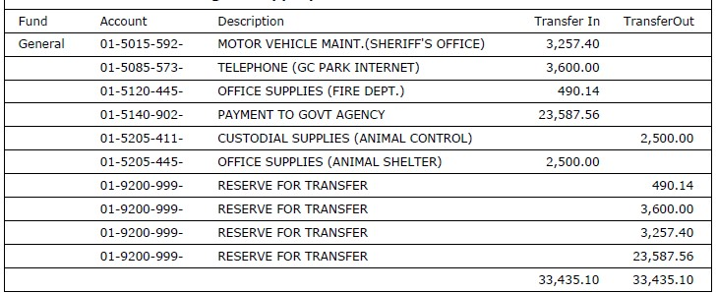
A motion was made by Mr. Livingston with second by Mr. Hostetler to approve the bills as presented and the following hand checks. Court voted unanimous.
Jail/ Gen $400,000.00, Circuit Clerk(PDB)/ Gen $730.78, Sheriff(PDB)/ Gen $140.00, Visa/ Gen $4,806.57
Mike Carroll from Brandstetter Carroll Engineering presented an updated design for a potential sheriff’s department/clerk satellite office and a design for a potential EMS station. He shared images and preliminary projected costs. Judge Covington stated that Financial Advisor, R.J. Palmer will attend an upcoming meeting to discuss the financial aspect and potential payment plans.
EMS Director, Chris Runyon requested to apply for a Health & Human Services (HHS) grant. The relief funds are for healthcare providers to help with expenses and lost revenue related to the pandemic. A motion was made by Mr. Corman with second by Mr. Hostetler approving application. Court voted unanimous.
Mr. Runyon requested to hire Zachary Greene full-time at $15.17 per hour. A motion was made by Mr. Lyons with second by Mr. Livingston to approve the new hire. Court voted unanimous.
Mr. Mudrak requested to grant an employee leave without pay until November 1st. Due to Health Insurance Portability and Accountability Act (HIPPA) personal information was not discussed. A motion was made by Mr. Corman with second by Mr. Burke to approve the temporary leave. Court voted unanimous.
Mr. Marshall read Order 21-01; an order approving a contract with Bluegrass Community Action for CDBG-CV grant funding assistance and authorizing the county judge executive to sign all relevant documents. A motion was made by Mr. Wallace with second by Mr. Corman to approve the order. Court voted unanimous.
Mr. Marshall read Order 21-02; an order approving a contract with Bluegrass Area Development District for CDBG-CV grant funding administration and authorizing the county judge executive to sign all relevant documents. A motion as made by Mr. Corman with second by Mr. Lyons to approve the order. Court voted unanimous.
Mr. Marshall read Resolution 21-11; a resolution of Scott County Fiscal Court regarding Title VI of The Civil Rights Act of 1964 and authorizing the county judge executive to execute all relevant documents. A motion was made by Mr. Wallace with second by Mr. Burke to approve the resolution. Court voted unanimous.
Mr. Marshall read Resolution 21-12; a resolution regarding CDBG procurement standards for the CDBG-CV project. A motion was made by Mr. Lyons with second by Mr. Corman to approve the resolution. Court voted unanimous.
Mr. Marshall read Resolution 21-13; a resolution regarding the CDBG-CV project, residential anti-displacement and relocation assistance plan under section 104(D) of The Housing and Community Development Act of 1974, as amended. A motion was made by Mr. Hostetler with second by Mr. Burke to approve the resolution. Court voted unanimous.
Judge Covington presented an updated Avaya agreement as the current operating system is being phased out and upgraded to Avaya Cloud Office. A motion was made by Mr. Hostetler with second by Mr. Corman to approve the agreement. Court voted unanimous.
Judge Covington presented a StepCG agreement for management of wired and wireless equipment ensuring optimum network performance at sixteen customer sites. A motion was made by Mr. Wallace with second by Mr. Burke to approve the agreement. Court voted unanimous.
Fire Chief, John Ward presented an updated Standing Operating Procedure related to promotional policy for battalion chief. He reviewed the guidelines for the promotional process. A motion was made by Mr. Lyons with second by Mr. Hostetler to approve the procedure. Court voted unanimous.
Human Resources Director, Jeff Mudrak presented an updated Covid19 paid leave policy for work-related exposure. After much discussion Judge Covington suggested reviewing the policy at the upcoming work session.
A motion was made by Mr. Corman with second by Mr. Livingston to adjourn. Court voted unanimous.

